Microprogrammed Control Unit
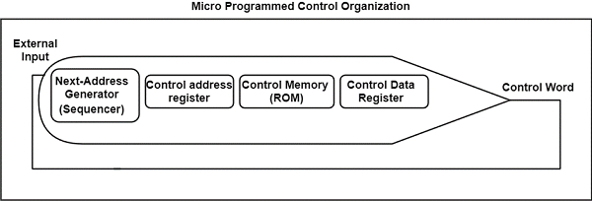
Fig: microprogram sequencer or nest address generator

